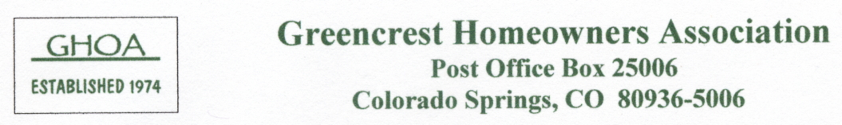

Neighborhood Block Coordinators
(May 2010)

For contact details, use in conjunction with the printed
Neighborhood Directory (Little Green Book)

Block # | Position | Name
1 | Coordinator | D. Bossett
 | Assistant Coordinator | D. Weatherford
2 | Coordinator | J. & P. Davidson
 | Assistant Coordinator | N. Fenlon
3 | Coordinator | M. Woodham
 | Assistant Coordinator | D. Harmon
4 | Coordinator | C. Avalos
 | Assistant Coordinator | D. Werschky
5 | Coordinator | E. Lawson
 | Assistant Coordinator | R. Winters
6 | Coordinator | V. Boals
 | Assistant Coordinator | M. Werschky
7 | Coordinator | S. Lawrence
 | Assistant Coordinator | E. Parker
8 | Coordinator | D. Laubscher
 | Assistant Coordinator | D. Wederquist

